Can the incineration of Municipal Solid Waste pose occupational and environmental radiation hazards?
Fernando P. Carvalho
Laboratório de Protecção e Segurança Radiológica, Instituto Superior Técnico/Campus Tecnológico e Nuclear, Universidade de Lisboa, PT (carvalho@itn.pt) ORCID: 0000-0002-1575-2788.
Article History  Received 30 December 2016  Accepted 7 June 2017  Published 1 September 2017  Keywords  solid urban waste  waste incineration  radionuclides  fly ash  radiation safety  DOI:  10.24840/2184-0954_00X.00X.00XX  ISSN:  2184-0954  Type:  Research Article  Open Access  Peer Reviewed  CC BY |  | Abstract  An evaluation of the incineration process of municipal solid waste is made for identifying potential radiation hazards. Sources of radiation considered are the radioactive materials wrongly eliminated into municipal waste (e.g., industrial and medical waste containing radioactive sources, such as cesium-137 and technetium-99m) and also radionuclides of natural origin (e.g., radium-226, polonium-210) contained in common materials disposed as domestic waste. Through burning, radionuclides from both origins may be released as gases and radioactive particles into the atmosphere and build up in the facility and in the environment nearby. Results from model calculations indicated that naturally-occurring radionuclides released into the atmosphere likely originate a small enhancement to the natural radiation background. However, in the case of man-made radioactive sources mixed with the municipal solid waste the radioactive emissions may attain and eventually exceed the radiation dose limit for members of the public. These results support the recommendation that for natural radionuclides present in incinerated waste a careful evaluation of the risk of exposure to ionizing radiation, actually in accord to the European Directive 2013/59/EURATOM establishing the basic safety standards for radiation protection, must be performed and model calculations validated with radioactivity measurements. Regarding the potential release of radionuclides from man-made radioactive sources it is recommended the installation of portals equipped with radiation detectors to check municipal solid waste on admission in the facilities and prevent such radiological accident.

1. INTRODUCTION
One of the new hazards identified in recent years in connection with high-temperature combustion processes is the volatilization of naturally-occurring radioactive elements present in raw materials and wastes submitted to melting or incineration. The release of radionuclides through volatilization and their eventual re concentration may result in exposure of facility workers and members of the public to enhanced radiation doses. It should be noted that this exposure to ionizing radiation may occur in industries other than those related to the nuclear fuel cycle and it was identified, for example, in steelworks, ceramics, coal-fired furnaces, among several industries using processes involving high temperatures (Trotti et al., 2008; Zampieri et al., 2008; Yan et al., 2012).
The European Union draw attention to radiological risks associated with several non-nuclear industries and, with the Directive 96/29/EURATOM (EU Directive 96/29) transferred responsibility to the Member States to assess radiation doses in such industries and compare them with legal dose limits in order to identify radiological risks. More recently, these responsibilities of EU Member States, together with radiation dose limits for workers and members of the public, have been revised in the Directive 59/2013/EURATOM (Directive 59/2013) which, after transposition by Member States to national regulations, replaces the previous Directive 96/29/EURATOM. The European Directive's resolutions are binding on States and stipulate that it is for EU Member States to identify and assess radiological risks and subsequently take the necessary measures in accordance with the procedures and dose limits set out in that Directive.
The presence of radioactive materials of anthropogenic origin (generally designated as radioactive sources) in industrial waste and municipal solid waste (MSW) was detected in several countries, and it will be reviewed below in section 3.1. In all these cases, the emission of radioactivity into the environment originated in inappropriate or negligent disposal of radioactive substances into MSW or with scrap metal intended for recycling. Inadequate disposal of radioactive substances into municipal sewerage systems has been reported also to originate detectable radioactive contamination of receiving aquatic systems in several European countries (Carvalho et al., 2013; Malta et al. 2013; Titley et al., 2000; Barquero et al., 2008).
International bodies, including the International Atomic Energy Agency (IAEA) and the OECD-Nuclear Energy Agency warn to the possibility that radioactive sources (sealed or unsealed) can be used in terrorist attacks to expose the population to radiation or to cause panic (Carvalho, 2009). In the prevention of these actions it has now become commonplace the installation of detection equipment at road borders, ports, and airports to detect the illegal transit of goods with radioactive sources and to hinder the illegal disposal of radioactive waste. Such measures contribute to ensure the radiological protection of the public.
In this precautionary move to ensure public safety and environmental health, municipal solid waste incinerators are no exceptions, especially when located in urban areas. In several European countries and in North America, the installation of ionizing radiation detectors has taken a long lead already, but this is not yet the case everywhere. Giving consideration to the new EU Directive 59/2013, it is timely and very important to assess the radioactivity hazards associated with the operation of municipal solid waste incinerators.
A preliminary evaluation of radiological hazards potentially associated with MSW incinerators is presented here, without reference to any specific facility.

2. MATERIALS AND METHODS
A preliminary evaluation of radiological hazards of a standard MSW incinerator facility is made on theoretical grounds with the purpose to identify and generically assess radiation hazards associated to such facility.
Firstly, the functioning of a typical MSW facility is reviewed in order to understand potential radioactivity sources and set up basic scenarios for occurrence of combustion and release of radioactive substances (Figure 1). Previous cases of accidental incineration of radioactive sources are reviewed also.
Secondly, the normal functioning of an incinerator for municipal solid wastes with typical (average) composition and without any added radioactive source is considered. In this scenario, only the naturally-occurring radionuclides contained in organic waste are considered and assessed as a source of radioactive hazard. Actual radionuclide concentrations measured in ashes and in atmospheric aerosols released from waste incinerators are presented and discussed to obtain additional insights into this potential radiological exposure pathway. These radionuclide measurements were made at a real MSW incinerating facility. The techniques of determination of the radionuclides, which include radiochemical separation and alpha spectrometry, were tested, validated and described in the international scientific literature (Carvalho et al., 2007; Oliveira and Carvalho, 2006).
Thirdly, calculations were performed using a generic model of radioactivity release and dispersion in the atmosphere, including radionuclide decay, proposed by the International Atomic Energy Agency, CROM version 8.0, to estimate radionuclide concentrations in the atmosphere in the vicinity of an emitting facility and human exposure to ionizing radiation (IAEA, 2001). It was assumed that radioactive materials were totally volatilized in the furnace, that emission into the atmosphere was from a chimney 50 meters high, with no tall buildings in the surroundings, and assuming a mild force wind transport with no dilution of radionuclides (Figure 2). Concentrations of radionuclides were calculated for several distances downwind the facility and the radiation dose to humans through inhalation was calculated, as well as radionuclide deposition on the ground.
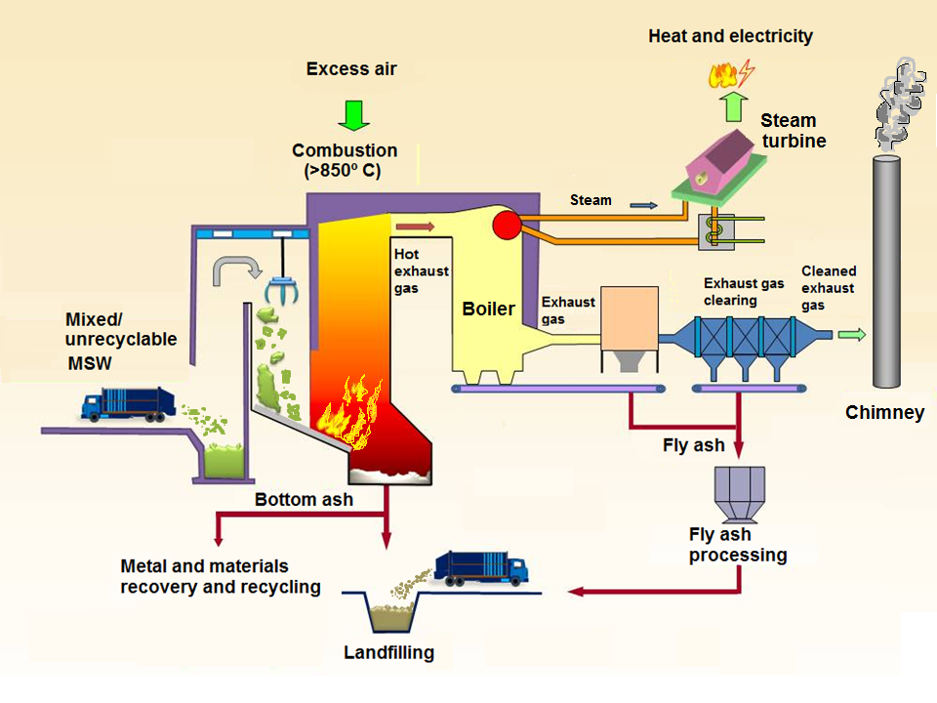
Figure 1. Scheme of municipal solid waste re collection aimed to incineration, operation of an incinerator, and final products (based on EPD, 2016).
For these model calculations two scenarios were considered. One for the radionuclide release from continuous burning of waste with average concentration of naturally-occurring radionuclides and without artificial radioactive sources added (continuous radionuclide release along the year), and the other for the accidental burning of a man-made radioactive source mixed with MSW (one isolated event with instantaneous release of radioactivity into the atmosphere).
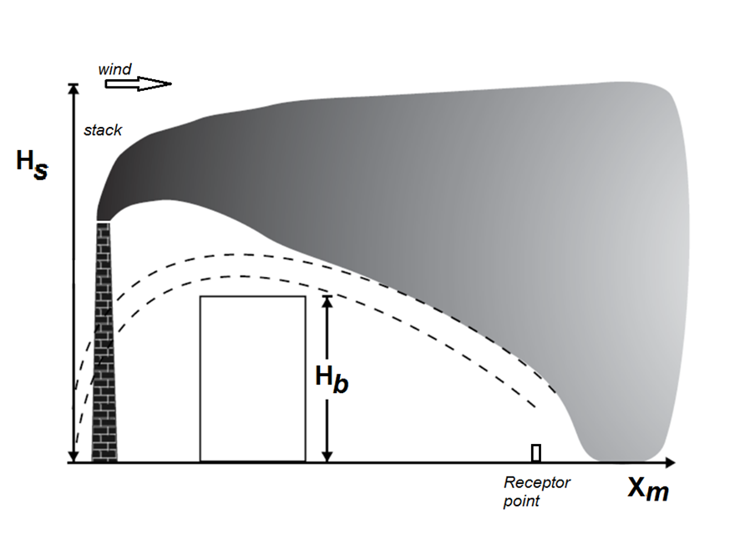
Figure 2. Basic scenario considered for generic evaluation of radionuclide emissions from the incinerator stack. Hs, height of the emission stack; Hb height of buildings; Xm, distance of receptor points to the emission stack (Based on CROM, vs8).

3. RESULTS AND DISCUSSION

3.1. Incineration of municipal solid waste and possible radiological hazards
The circuit of municipal solid waste (MSW) collection and treatment comprises several steps (Figure 1). Current configuration of the waste receiving stream at the incineration plants in Portugal allows the discharge of the entire contents of the MSW collection trucks to the pit of incinerating plant. Prior to incineration, waste sorting is applied for the separation of ferrous and glass residues which are forwarded to scrapers for recycling (Brito Vaz, 2006; Fernandes, 1999).
All natural organic and geological materials contain some radioactivity of natural origin due to radionuclides of uranium, thorium, and actinium natural series and potassium-40 (⁴⁰K) but, generally, these radionuclides are present in low concentrations (Eisenbud and Gesell, 1997; UNSCEAR, 2008; Carvalho et al., 2014). These radionuclides are thus naturally-occurring in the composition of materials that make the common municipal solid waste.
Other radionuclides may occur as a result of man-made radioactive substances. A man-made radioactive substance mixed in MSW may take any form, i.e., it may be an item made of cardboard, textile, plastic, glass, aluminum, or other metal containing radioactive elements such as ¹³¹I, ^{99m}Tc ¹³⁷Cs, ⁷⁵Se, ⁶⁰Co, ²⁴¹Am, or other. These may originate from medical applications (e.g., sealed and unsealed sources used in radiotherapy and nuclear medicine), industrial applications (e.g., non-destructive testing and gauge detectors), and common devices available to the public (e.g., fire and smoke detectors used in car parks and buildings). These radioactive sources, especially those that have reached the end of their useful life can be discarded (albeit incorrectly and illegally) in the common waste, or inadvertently mixed with MSW in any facility where they have been used. They may be also intentionally and malevolently mixed with MSW. Properties of some common man made radionuclides are given in Table 1.
In most MSW incinerating facilities, current equipment installed does not permit the detection of radioactive materials and, therefore, these may be inadvertently accepted into incinerator furnaces. The incineration of these radioactive sources in furnaces with temperatures attaining from 850⁰ C up to 1300⁰ C, may lead to the emission of radioactive vapor and radioactive particles into the atmosphere. In the most serious cases, such an occurrence may have a radiological impact on the environment and population, and it is very likely to contaminate also the incinerator facilities and the mass of slag (bottom ash) and fly ash produced.
Cases of accidental incineration of radioactive sources have been reported, such as the fusion of a source of radioactive cesium (¹³⁷Cs) mixed with metal scrap in the Acerinox steelworks in Algeciras, Spain (Estevan, 2004); the volatilization of radioactive iodine (¹³¹I) from hospital waste in the MSW incinerator of the city of Milan, Italy; the fusion of abandoned (“orphan”) radioactive sources (¹³⁷Cs and ⁶⁰Co) into melting furnaces and incinerators in the United States on several occasions (Ronchin et al., 2011). Although in a different environment and different circumstances, the release of ¹³⁷Cs from incineration of MSW contaminated by radioactivity from the Fukushima nuclear accident, in Japan, was also investigated and reported (Oshita et al., 2015). The severity of the radiological impact from these accidents may vary from minor (e.g., incineration of radioactive residue from treatment of a cancer patient who has returned home), to very serious, such as the volatilization of a source of cesium (¹³⁷Cs) in the Algeciras steelworks in 1997, which gave rise to a radioactive cloud detected in France (Estevan, 2004).
The radiation dose from such an incident to members of the public may, thus, vary from some nanosievert (nSv) added to the natural radioactive background, to more than 1 milisievert (mSv), i.e., the maximum annual tolerated dose or annual dose limit, added to the natural radioactive background, as established by Directive 59/2013/EURATOM. If radiation exposure exceeds the dose limit for elements of the public, then negative impacts on human health have increased probability to occur and the liability of the facility owner may be invoked. To the workers of the incineration plant, which are not classified as “radiation workers” (i.e., exposed to ionizing radiation in their job and enrolled in a radiation protection programme), the dose limit of 1 mSv per year (1 mSv a⁻¹) shall also apply for their protection against the biological effects of ionizing radiation, as for the members of the public (European Directive 59/2013).

3.2. Radiological hazards associated with the normal operation of the MSW incineration facility in the absence of artificial radioactive sources
The combustion of common municipal solid wastes, with no added radioactive sources, releases the natural radioactivity they contain, as discussed above.
The radionuclide concentrations in common items of municipal solid waste were compiled from previous work (Carvalho, 1995; Carvalho et al., 2014). Materials such as remainders of meals including meat, fish, potatoes, bread, vegetables and fruits were considered, as well as remainders of plants, paper and cardboard. Most of these materials display low concentrations of ²²⁶Ra, ²¹⁰Pb and ²¹⁰Po radionuclides of natural origin, and average values fall in the range from 1 to 10 Bq kg⁻¹ dry weight (Figure 3). The combustion of such municipal solid waste causes volatilization and eventual re concentration of these radionuclides.
Assuming that the incineration facility receives 2000 tons of MSW per day and containing 80% of combustible (organic waste), around 550,000 tons of organic waste might be incinerated per year. Applying the average concentrations of radionuclides determined in organic materials (Figure 3), the total annual radioactivity in incinerated waste will be 5.50x10⁸Bq of ²²⁶Ra, 1.98x10⁹ Bq of ²¹⁰Pb, and 4.62x10⁹ Bq of ²¹⁰Po. These annual figures are impressive (and there are more radionuclides present). The actual radioactivity released from a MSW incinerator into the atmosphere is not known, although it is likely that a fraction of the total will be retained with the slag and fly ash and actually not released into the atmosphere.
The estimation of radionuclide concentrations in surface air was performed using a computer code (CROM, version 8) based on procedures recommended by the International Atomic Energy Agency (IAEA, 2001).
Assuming the worst case scenario, i.e., no retention of radionuclides in the bottom ash and fly ash captured in the facility, the incineration with release of those annual activities into the atmosphere could generate radionuclide concentrations in the air, at a location 1000 meters distance from the chimney, of 30 µBq m⁻³ of ²²⁶Ra, 100 µBq m⁻³ of ²¹⁰Pb, and 250 µBq m⁻³ of ²¹⁰Po. These concentrations would be about one order of magnitude higher than the natural radiation background of Lisbon surface air for ²¹⁰Pb and ²¹⁰Po, and the deposition of ²¹⁰Pb and ²¹⁰Po on the ground around the facility could duplicate the natural atmospheric deposition flux (Carvalho, 1995).
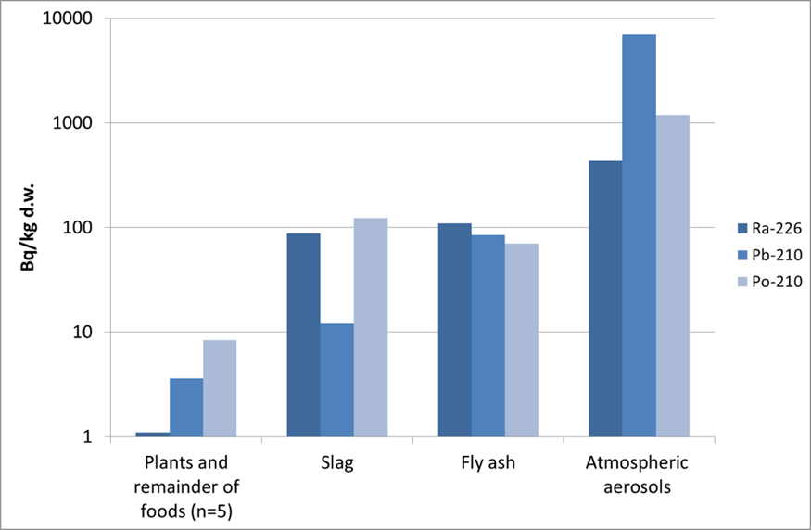
Figure 3. Comparison of average radionuclide concentrations (Bq/kg dry weight) in materials commonly present in municipal solid waste (plants, paper, and remainder of foods), slag and fly ashes from an MSW incinerator and atmospheric aerosols near the incinerating facility.
Model calculations for the annual load of MSW incinerated and annual total activities of radionuclides ²²⁶Ra, ²¹⁰Pb, and ²¹⁰Po showed that the normal operation of an incinerator can originate effective radiation doses through inhalation of the order of nSv a⁻¹ or lower (Table 2). Assuming that fly ash control in facility retains 50% of the radionuclide load present in the MSW, the concentration of radionuclides in the air, and the resulting radiation dose to man, would be reduced to values half of those reported above. Therefore, the increase of radiation exposure added to the natural radioactive background will occur but would be of low radiological significance in comparison with the annual dose limit for members of the public, 1 mSv a⁻¹.
Results of the analysis of radionuclides in slag, fly ash, and atmospheric aerosols collected in surface air outside an incineration facility were reported before (Carvalho et al., 2016). Results showed re concentration of some radionuclides (the most important ones in terms of human exposure, such as radium, radioactive lead and polonium) in furnace slag and fly ash (Figure 3). Actually, the bottom ashes of the boiler (furnace slag) contained concentrations of 121±4 Bq kg⁻¹ of ²³⁸U, 88±18 Bq kg⁻¹ of ²²⁶Ra, and 123±8 Bq kg⁻¹ of ²¹⁰Po. High concentrations of ²²⁶Ra, 110±8 Bq kg⁻¹, were also determined in the fly ashes retained in bag filters. In the vicinity of the incinerator, radionuclide concentrations in surface air aerosols ranged from 1000 to 10 000 Bq kg⁻¹, demonstrating an enhancement of radionuclide concentrations from release of radioactivity of the MSW into atmosphere (Figure 3).

Table 1. Common radionuclides used in medical and industrial applications, their radioactive half-lives, common chemical compounds and respective melting point temperatures.
Radionuclide | Radioactive  half-life (T_{1/2}) | Common compounds | Melting point temperature (ºC) | Application
Iodine-124  (¹²⁴I) | 4.2 day | ICl; ICl₃ | 97 ºC | Medical
Iodine-131  (¹³¹I) | 8 days | ICl; ICl₃ | 97 ºC | Medical
Technetium-99m  (^{99m}Tc) | 6 hours | TcO₄;  ^{99m}Tc labelled bisphosphonate compounds | Element 4265 °C.  Compounds ca. 10²-10^{3 º}C | Medical
Technetium-95  (⁹⁵Tc) | 61 days | TcF₆; | 55 ºC -… | Medical
Selenium-75  (⁷⁵Se) | 120 days | SeCl₂ | 288 ºC | Industrial and medical
Cobalt-60  (⁶⁰Co) | 5.2 years | CoCl₂ | 1049 ºC | Industrial
Caesium-137  (¹³⁷Cs) | 30 years | CsCl | 1290 ºC | Industrial
These results show that incineration of natural materials (MSW) releases naturally-occurring radionuclides into the atmosphere. Such releases enhance radionuclide concentrations in surface air and add some radiation exposure to the population, including facility workers and members of the public in the vicinity. Although likely to be a minor enhancement of environmental radiation exposure, this potential hazard should be further assessed on the basis of systematic radionuclide measurements.
Periodically, the furnaces are stopped for maintenance, including for reinforcement of the inner surface of furnaces. During maintenance works, the access to furnace interior can expose workers to ionizing radiations from inhalable dust (slag) and from the cement and refractory bricks of the furnace liner. In these refractory bricks generally is used zirconium, an element resistant to high temperatures that contains oxides of uranium and thorium. The risk of occupational radiation exposure during the furnace maintenance and cleaning of bag filters should be assessed also.
Final residues of waste incineration, ash and slag, are currently disposed of with immobilization in cement and landfilling. Although immobilization of radionuclides by these disposal methods may not be eternal, in the light of current knowledge it seems to be an effective way of inertifying the ashes, slags, and radioelements they contain. However, it is also known that in several countries the valorization of waste from incineration is sought through the use of ash incorporation in other materials (Toller et al., 2009). As waste recycling is increasingly encouraged, the radionuclide content of ash should be determined and radiological risk assessed before application.
Taking into account the outcome of model calculations and a few preliminary radionuclide measurements referred above, an in-depth radiological assessment of the contribution of naturally-occurring radionuclides to radiation doses to humans and to the environment should be made for the operation of MSW incineration plants and its products. Actually, this is recommended by the EU Directive 2013/59 and the responsibility of such evaluation is transferred to the EU Member States.

3.3.1. Radiological hazards associated with the incineration of artificial radioactive sources added to the MSW
The combustion of man-made radioactive sources mixed in municipal solid wastes may release artificial radionuclides, as discussed above.
The combustion of a ¹³⁷Cs source with 3.7x10⁸ Bq (10 mCi) activity could generate a radioactive aerosol in surface air at the surroundings of the facility with a maximum value at around 1km off site and decreasing with increasing distance. Following cesium release, radionuclide concentration in the surface air could attain 6.3x10² Bq m⁻³ and deposition on the ground would be 6.3x10⁵ Bq m⁻² per day, at the same location. Other exposure pathways, such as cesium transfer from soil to crops to man, following the deposition of radionuclide on the ground, could contribute further to human exposure due to the long half-life, 30 years, of this radionuclide (Figure 3).
The combustion of a source of ¹³¹I with the same activity, 3.7x10⁸ Bq (10 mCi), would generate similar activity concentrations in the surface air and deposition onto the ground. However, the much shorter half-life of this radionuclide, 8.0 days, would account for its rapid radioactive decay and shorter period of human exposure. Similar computation was made for the incineration of a “Technetium generator”, which is based on a source of radioactive molybdenum ⁹⁹Mo to obtain the ^{99m}Tc daily used in nuclear medicine. The subsequent activity released from the chimney into the atmosphere, the radionuclide concentration in the air, the radiation dose by inhalation to people nearby, and radionuclide deposition in soil are shown in Table 2.
For the radionuclides considered, ¹³¹I is likely the one that may originate the higher radiation dose to humans through inhalation. Volatilization of a radioactive source of ¹³¹I with 100 mCi, may originate an effective dose of 1 mSv in one day of exposure (Table 2). One may compare this dose with the legal limit of 1 mSv in one year, for members of the public.
Table 2. Radionuclide emissions into the atmosphere from MSW incineration. It was assumed that naturally-occurring radionuclides are released continuously over the year, and artificial radionuclides are released instantaneously and as a single event.
Radionuclide | Emission | Concentration  in the air  (Bq m⁻³) | Radiation dose  from inhalation  (Sv d⁻¹) | Deposition on soils  (Bq m⁻² a⁻¹)
Naturally-occurring radionuclides in MSW:

²²⁶Ra | 5.50x10⁸  Bq a⁻¹ | 3.0x10⁻⁵ | 2.40x10⁻¹⁰ | 10
²¹⁰Pb | 1.98x10⁹  Bq a⁻¹ | 1.0x10⁻⁴ | 1.98x10⁻⁹ | 39
²¹⁰Po | 4.62x10⁹  Bq a⁻¹ | 2.5x10⁻⁴ | 3.35x10⁻⁹ | 90
Artificial radionuclides mixed in MSW:

¹³⁷Cs | 3.7x10⁹  Bq s⁻¹  (100 mCi) | 6.35x10³ | 6.42x10⁻⁴ | 2.31x10⁹
¹³¹I | 3.7x10⁹  Bq s⁻¹  (100 mCi) | 6.35x10³ | 1.03x10⁻³ | 2.31x10⁹
^{99m}Mo-  ^{99m}Tc | 3.7x10⁹  Bq s⁻¹  (100 mCi) | 6.35x10³ | 1.67x10⁻⁶ | 2.31x10⁹
In the incinerator facility the burning of a radioactive source mixed with the MSW will create also contamination of the furnace, the slag and fly ash retained on filters. This could create additional occupational exposure problems for the maintenance of the furnace, and for the transportation and disposal of slag and fly ash that will become radioactive residues.
It is underlined that these estimates of radionuclide releases into the atmosphere are generic and not tailored for any specific incineration facility. The purpose was to evaluate whether the release of radioactivity is likely to occur and whether a potential radiological hazard may exist or not. The model calculations made have indicated that concentration of natural radionuclides is likely to occur in the incineration process and the release of radioactivity into the environment is likely to occur also, although the radiological risk might be of low level in the case of naturally-occurring radionuclides. However, the incineration of an artificial radioactive source added to the MSW may originate higher radiation exposures through atmospheric pathways. Therefore, site specific calculations for each incinerating facility, using data related to the facility and to the environment of the region, must be performed in order to obtain an accurate assessment of the radiological impact and radiological risk. Validation of estimates shall also be carried out through measurements of radioactivity in and around the incinerator facilities.

4. CONCLUSIONS
Model calculations and measurements reported above indicate that incineration of municipal solid waste may originate enhanced exposure to radioactive elements and ionizing radiation.
The incineration process leads to the concentration of naturally-occurring radionuclides present in MSW into slag, fly ash and their release with the gas emissions into the atmosphere also. This re concentration of naturally-occurring radionuclides is intrinsic to the incineration process. Radiation exposure hazards must be controlled by the adoption of good working practices and hygiene measures to optimize radiation protection of workers. The composition of the slag and ash to be reused or landfilled should also be monitored for verification of compliance with specifications for their re use or disposal in landfills.
The admission of radioactive substances of anthropogenic origin (man-made radioactive sources) mixed with the MSW creates radiological hazards extrinsic to the incineration process. In the event of such an accident, the radiological risk for workers in the incineration plant (occupational risk) and for the public (environmental risk) will vary and depends on the incinerated radioactive material. This type of radiological accident can be prevented by the installation of portals with ionizing radiation detectors on the admission of MSW into premises. The detection of radioactivity in a timely manner may allow for segregation of the radioactive source before incineration. Radiation detection portals can help also with the monitoring of radioactivity in slag and ash loads leaving the facility, allowing timely checking of their compliance with landfill legislation.
Calculations and measurements indicate that radiation exposure hazards may occur in relationship with the incineration of MSW and, in the case of man-made radioactive sources mixed in the MSW, radiation doses may exceed legal limits. Therefore, installation of portals with radiation detectors is advised to prevent such radiological accident in incinerators.

ACKNOWLEDGEMENTS
This study was funded by the FCT – Portuguese National Funding Agency for Science, Research and Technology (SFRH/BD/90794/2012).

References
Barquero, R., Agulla, M.M., Ruiz, A. (2008). Liquid discharges from the use of radionuclides in medicine (diagnosis). Journal of Environmental Radioactivity, 99 (10): 1535-1538.
Brito Vaz, F. S. (2009). As características da fracção orgânica dos RSU recolhidos selectivamente na Área Metropolitana de Lisboa e a sua influência no comportamento do processo de digestão anaeróbia. Master Science Thesis (In Portuguese), Faculdade de Ciências e Tecnologia, Universidade Nova de Lisboa.
Carvalho, F. P., Oliveira, J. M., Malta, M. (2014). Exposure to radionuclides in smoke from vegetation fires. Science of the Total Environment 472: 421–424.
Carvalho, F. P., Oliveira, J. M., Malta, M. (2016). Incineração dos Resíduos Sólidos Urbanos e Risco de Exposição a Substâncias Radioactivas (Incineration of Municipal Solid Waste and Risk of Exposure to Radioactive Substances). In: Proceedings Book of International Symposium on Occupational Safety and Hygiene, pp 37-39. P. Arezes et al. (Ed), SPOSHO 2016. ISBN-978-989-98203-6-4.
Carvalho, F. P. (2009). The Threats and Challenges of a Radiological Emergency. In: Disaster Management 2009. K.A. Duncan and C.A. Brebbia (Eds), pp. 45-53. WIT Press, United Kingdom.
Carvalho, F. P. (1995). 210Po and 210Pb intake by the Portuguese population: the contribution of seafood in the dietary intake of 210Po and 210Pb. Health Physics 69(4): 469-480.
Carvalho, F. P., Oliveira J. M. (2007). Alpha emitters from uranium mining in the environment. Journal of Radioanalytical and Nuclear Chemistry, 274: 167-174.
Carvalho, F. P., Oliveira, J. M., Silva, L., Malta, M. (2013). Radioactivity of anthropogenic origin in the Tejo Estuary and need for improved waste management and environmental monitoring. International Journal of Environmental Studies 70 (6): 952-963. DOI: 10.1080/00207233.2013.845714.
European Directive 59/2013. DIRETIVA 2013/59/EURATOM DO CONSELHO de 5 de Dezembro de 2013 que fixa as normas de segurança de base relativas à protecção contra os perigos resultantes da exposição a radiações ionizantes, e que revoga as Directivas 89/618/Euratom, 90/641/Euratom, 96/29/Euratom, 97/43/Euratom e 2003/122/Euratom. Jornal Oficial Nº L 13 de 17/1/2014, p.01-72.
European Directive 96/29. Directiva 96/29/Euratom do Conselho de 13 de Maio de 1996 que fixa as normas de segurança de base relativas à protecção sanitária da população e dos trabalhadores contra os perigos resultantes das radiações ionizantes. Jornal Oficial nº L 159 de 29/06/1996 p. 0001–0114.
Eisenbud, M. and Gesell, T. (1997). Environmental Radioactivity from Natural, Industrial, and Military Sources. 4th Edition. Elsevier.
EPD (2016). Environmental Protection Department, The Government of Hong Kong, Spetial administrative Region. http://www.epd.gov.hk/epd/english/environmentinhk (accessed: 22 Dec 2016).
Estevan, M. T. (2014). Consequences of the Algeciras accident, and the Spanish system for the radiological surveillance and control of scrap and the products of its processing. Proceedings of an international conference on Security of radioactive sources held in Vienna, Austria, 10–13 March 2003. International Atomic Energy Agency, Vienna. http://www-pub.iaea.org/MTCD/publications/PDF/Pub1165_web.pd.
Fernandes, P. A. L. (1999). Estudo Comparativo e Avaliação de Diferentes Sistemas de Compostagem de Resíduos Sólidos Urbanos. Master Science Thesis (In Portuguese). Universidade de Coimbra, Faculdade de Ciências e Tecnologia, Departamento de Engenharia Civil.
IAEA (2001). Generic models for use in assessing the impact of discharges of radioactive substances to the environment. Safety Report Series Nº 19. International Atomic Energy, Vienna.
Malta, M., Oliveira, J. M., Silva, L., Carvalho, F. P. (2013). Radioactivity from Lisboa urban wastewater discharges in the Tejo River Estuary. Journal of Integrated Coastal Zone Management 13 (4): 399-408. DOI: 10.5894/rgci339.
NORM V (2008). Naturally-occurring radioactive material (NORM V). Proceedings of the Fifth International Symposium On Naturally-Occurring Radioactive Material, held in Seville, Spain, 19–22 March 2007. International Atomic Energy Agency, Vienna, 2008.
Oliveira, J. M., Carvalho, F. P. (2006). A Sequential Extraction Procedure for Determination of Uranium, Thorium, Radium, Lead and Polonium Radionuclides by Alpha Spectrometry in Environmental Samples. (Proceedings of the 15th Radiochemical Conference). Czechoslovak Journal of Physics, 56 (Suppl. D): 545-555.
Oshita, K., Aoki, H., Fukutani, S., Shiota, K., Fujimori, T., Takaoka, M. (2015). Behavior of cesium in municipal solid waste incineration. J Environ Radioact 143:1-6.
Ronchin, G. P., Campi, F., Porta, A. (2011). Incineration of urban solid waste containing radioactive sources. Radiation Measurements 46: 133-140.
Titley, J. G., Carey, A. D., Crockett, G. M., Ham, G. J., Harvey, M. P., Mobbs, S. F., Tournette, C., Penfold, J. S. S., Wilkins, B. (2000). Investigation of the Source and Fate of Radioactive Discharges to Public Sewers. Technical Report P288. Environment Agency, UK.
Toller, S., Karrman, E., Gustafsson, J. P., Magnusson, Y. (2009). Environmental assessment of incinerator residue utilization. Waste management 29: 2071.2077.
Trotti, F., Zampieri, C., Caldognetto, E., Ocone, R., Di Lillo, A., Magro, L., Jia, G., Torri, G. (2008). A study concerning NORM in integrated steelworks. In: Proceedings of NORM V Conference. IAEA Proceedings Series, (2008) 351-354.
UNSCEAR (2008). Sources and effects of ionizing radiation, Vol. I. United Nations Scientific Committee on the Effects of Atomic Radiation, Report to the General Assembly. United Nations, New York.
Yan, G., Cho, H-M., Lee, I., Kim, G. (2012). Significant emissions of 210Po by coal burning into the urban atmosphere of Seoul, Korea. Atmospheric Environment 54, 80-85.
Zampieri, C., Trotti, F., Andreoli, F., Ballarin Denti, A. (2008). NORM in the Italian tile and refractory industries. In: Proceedings of NORM V Conference. IAEA Proceedings Series, pp. 141-148, International Atomic Energy Agency, Vienna.

